Southwestern Oklahoma State University OEQA Mentor Report 2022
OEQA Mentor/Administrator Survey 2022
June 21st 2022, 8:40 am CDT
Q2 - The person completing this survey is:
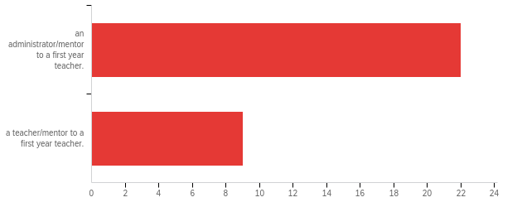

# | Field | Minimum | Maximum | Mean | Std Deviation | Variance | Count
1 | The person completing this survey is: | 1.00 | 2.00 | 1.29 | 0.45 | 0.21 | 31

# | Answer | % | Count
1 | an administrator/mentor to a first year teacher. | 70.97% | 22
2 | a teacher/mentor to a first year teacher. | 29.03% | 9
 | Total | 100% | 31

Q3 - The Learner and Learning Please rate the extent to which you agree that each statement is true of [ExternalDataReference].
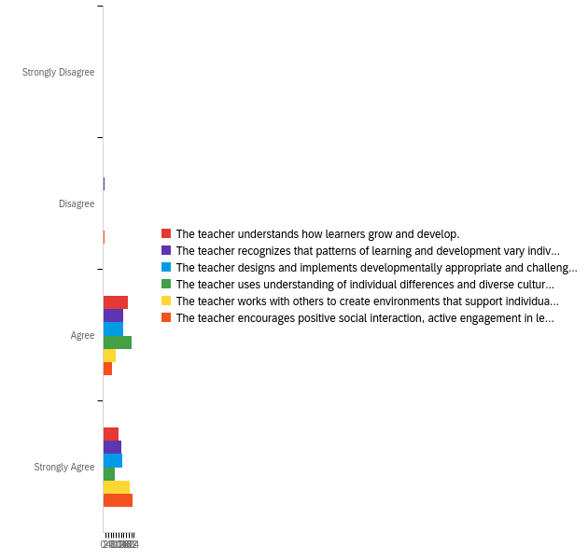

# | Field | Minimum | Maximum | Mean | Std Deviation | Variance | Count
1 | The teacher understands how learners grow and develop. | 3.00 | 4.00 | 3.39 | 0.49 | 0.24 | 31
2 | The teacher recognizes that patterns of learning and development vary individually within and across the cognitive, linguistic, social, emotional, and physical areas. | 2.00 | 4.00 | 3.42 | 0.55 | 0.31 | 31
3 | The teacher designs and implements developmentally appropriate and challenging learning experiences. | 3.00 | 4.00 | 3.48 | 0.50 | 0.25 | 31
4 | The teacher uses understanding of individual differences and diverse cultures and communities to ensure inclusive learning environments that enable each learner to meet high standards. | 3.00 | 4.00 | 3.29 | 0.45 | 0.21 | 31
5 | The teacher works with others to create environments that support individual and collaborative learning. | 3.00 | 4.00 | 3.68 | 0.47 | 0.22 | 31
6 | The teacher encourages positive social interaction, active engagement in learning, and self-motivation. | 2.00 | 4.00 | 3.71 | 0.52 | 0.27 | 31

# | Question | Strongly Disagree |  | Disagree |  | Agree |  | Strongly Agree |  | Total
1 | The teacher understands how learners grow and develop. | 0.00% | 0 | 0.00% | 0 | 61.29% | 19 | 38.71% | 12 | 31
2 | The teacher recognizes that patterns of learning and development vary individually within and across the cognitive, linguistic, social, emotional, and physical areas. | 0.00% | 0 | 3.23% | 1 | 51.61% | 16 | 45.16% | 14 | 31
3 | The teacher designs and implements developmentally appropriate and challenging learning experiences. | 0.00% | 0 | 0.00% | 0 | 51.61% | 16 | 48.39% | 15 | 31
4 | The teacher uses understanding of individual differences and diverse cultures and communities to ensure inclusive learning environments that enable each learner to meet high standards. | 0.00% | 0 | 0.00% | 0 | 70.97% | 22 | 29.03% | 9 | 31
5 | The teacher works with others to create environments that support individual and collaborative learning. | 0.00% | 0 | 0.00% | 0 | 32.26% | 10 | 67.74% | 21 | 31
6 | The teacher encourages positive social interaction, active engagement in learning, and self-motivation. | 0.00% | 0 | 3.23% | 1 | 22.58% | 7 | 74.19% | 23 | 31

Q4 - Content Please rate the extent to which you agree that each statement is true of [ExternalDataReference].
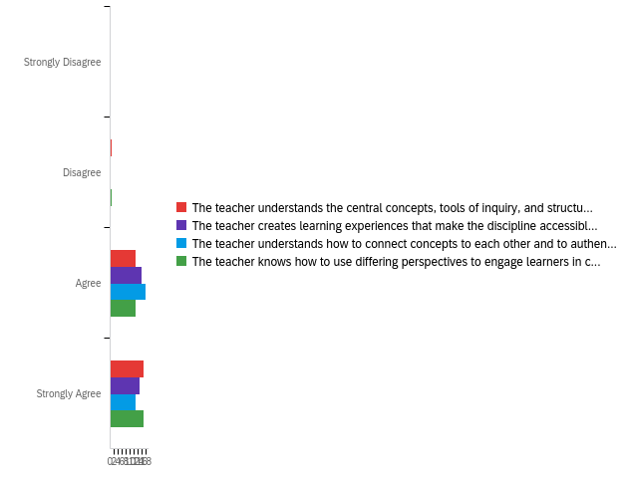

# | Field | Minimum | Maximum | Mean | Std Deviation | Variance | Count
1 | The teacher understands the central concepts, tools of inquiry, and structures of the discipline(s) he or she teaches. | 2.00 | 4.00 | 3.52 | 0.56 | 0.31 | 31
2 | The teacher creates learning experiences that make the discipline accessible and meaningful for learners to assure mastery of the content. | 3.00 | 4.00 | 3.48 | 0.50 | 0.25 | 31
3 | The teacher understands how to connect concepts to each other and to authentic local and global issues. | 3.00 | 4.00 | 3.42 | 0.49 | 0.24 | 31
4 | The teacher knows how to use differing perspectives to engage learners in critical thinking, creativity, and collaborative problem solving. | 2.00 | 4.00 | 3.52 | 0.56 | 0.31 | 31

# | Question | Strongly Disagree |  | Disagree |  | Agree |  | Strongly Agree |  | Total
1 | The teacher understands the central concepts, tools of inquiry, and structures of the discipline(s) he or she teaches. | 0.00% | 0 | 3.23% | 1 | 41.94% | 13 | 54.84% | 17 | 31
2 | The teacher creates learning experiences that make the discipline accessible and meaningful for learners to assure mastery of the content. | 0.00% | 0 | 0.00% | 0 | 51.61% | 16 | 48.39% | 15 | 31
3 | The teacher understands how to connect concepts to each other and to authentic local and global issues. | 0.00% | 0 | 0.00% | 0 | 58.06% | 18 | 41.94% | 13 | 31
4 | The teacher knows how to use differing perspectives to engage learners in critical thinking, creativity, and collaborative problem solving. | 0.00% | 0 | 3.23% | 1 | 41.94% | 13 | 54.84% | 17 | 31

Q5 - Instructional Practice Please rate the extent to which you agree that each statement is true of [ExternalDataReference].
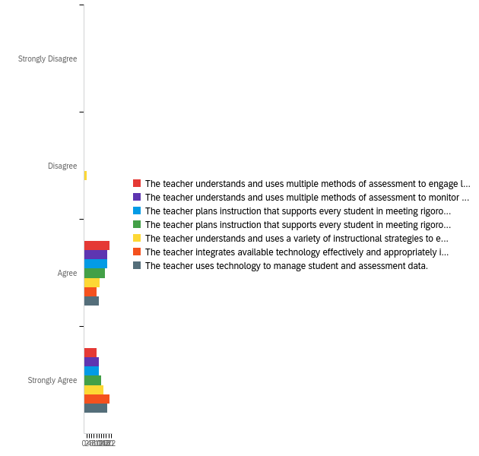

# | Field | Minimum | Maximum | Mean | Std Deviation | Variance | Count
1 | The teacher understands and uses multiple methods of assessment to engage learners in their own growth and guide learners' decision making. | 3.00 | 4.00 | 3.32 | 0.47 | 0.22 | 31
2 | The teacher understands and uses multiple methods of assessment to monitor learner progress and to guide his/her decision making. | 3.00 | 4.00 | 3.39 | 0.49 | 0.24 | 31
3 | The teacher plans instruction that supports every student in meeting rigorous learning goals by drawing upon knowledge of content areas, curriculum, cross-disciplinary skills, and pedagogy. | 3.00 | 4.00 | 3.39 | 0.49 | 0.24 | 31
4 | The teacher plans instruction that supports every student in meeting rigorous learning goals by drawing upon knowledge of learners and the community context. | 3.00 | 4.00 | 3.45 | 0.50 | 0.25 | 31
5 | The teacher understands and uses a variety of instructional strategies to encourage learners to develop deep understanding of content areas and their connections, and to build skills to apply knowledge in meaningful ways. | 2.00 | 4.00 | 3.45 | 0.61 | 0.38 | 31
6 | The teacher integrates available technology effectively and appropriately into instruction. | 3.00 | 4.00 | 3.68 | 0.47 | 0.22 | 31
7 | The teacher uses technology to manage student and assessment data. | 3.00 | 4.00 | 3.61 | 0.49 | 0.24 | 31

# | Question | Strongly Disagree |  | Disagree |  | Agree |  | Strongly Agree |  | Total
1 | The teacher understands and uses multiple methods of assessment to engage learners in their own growth and guide learners' decision making. | 0.00% | 0 | 0.00% | 0 | 67.74% | 21 | 32.26% | 10 | 31
2 | The teacher understands and uses multiple methods of assessment to monitor learner progress and to guide his/her decision making. | 0.00% | 0 | 0.00% | 0 | 61.29% | 19 | 38.71% | 12 | 31
3 | The teacher plans instruction that supports every student in meeting rigorous learning goals by drawing upon knowledge of content areas, curriculum, cross-disciplinary skills, and pedagogy. | 0.00% | 0 | 0.00% | 0 | 61.29% | 19 | 38.71% | 12 | 31
4 | The teacher plans instruction that supports every student in meeting rigorous learning goals by drawing upon knowledge of learners and the community context. | 0.00% | 0 | 0.00% | 0 | 54.84% | 17 | 45.16% | 14 | 31
5 | The teacher understands and uses a variety of instructional strategies to encourage learners to develop deep understanding of content areas and their connections, and to build skills to apply knowledge in meaningful ways. | 0.00% | 0 | 6.45% | 2 | 41.94% | 13 | 51.61% | 16 | 31
6 | The teacher integrates available technology effectively and appropriately into instruction. | 0.00% | 0 | 0.00% | 0 | 32.26% | 10 | 67.74% | 21 | 31
7 | The teacher uses technology to manage student and assessment data. | 0.00% | 0 | 0.00% | 0 | 38.71% | 12 | 61.29% | 19 | 31

Q6 - Professional Responsibility Please rate the extent to which you agree that each statement is true of [ExternalDataReference].
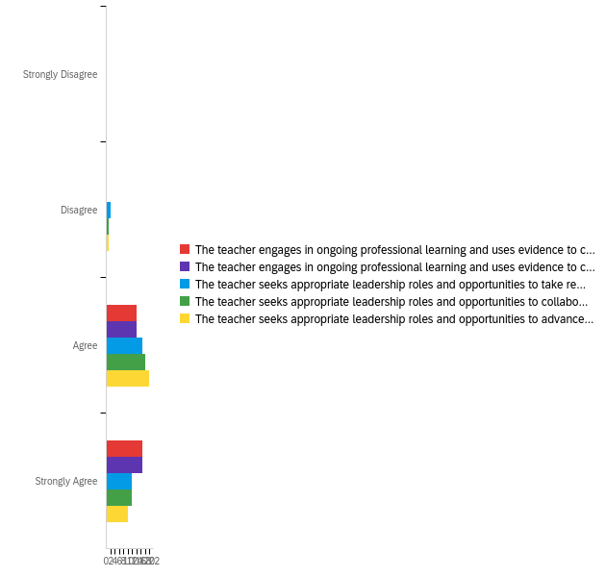

# | Field | Minimum | Maximum | Mean | Std Deviation | Variance | Count
1 | The teacher engages in ongoing professional learning and uses evidence to continually evaluate his/her practice, particularly the effects of his/her choices and actions on others (learners, families, other professionals, and the community). | 3.00 | 4.00 | 3.55 | 0.50 | 0.25 | 31
2 | The teacher engages in ongoing professional learning and uses evidence to continually adapt practice to meet the needs of each learner. | 3.00 | 4.00 | 3.55 | 0.50 | 0.25 | 31
3 | The teacher seeks appropriate leadership roles and opportunities to take responsibility for student learning. | 2.00 | 4.00 | 3.32 | 0.59 | 0.35 | 31
4 | The teacher seeks appropriate leadership roles and opportunities to collaborate with learners, families, colleagues, other school professionals, and community members to ensure learner growth. | 2.00 | 4.00 | 3.35 | 0.54 | 0.29 | 31
5 | The teacher seeks appropriate leadership roles and opportunities to advance the profession. | 2.00 | 4.00 | 3.29 | 0.52 | 0.27 | 31

# | Question | Strongly Disagree |  | Disagree |  | Agree |  | Strongly Agree |  | Total
1 | The teacher engages in ongoing professional learning and uses evidence to continually evaluate his/her practice, particularly the effects of his/her choices and actions on others (learners, families, other professionals, and the community). | 0.00% | 0 | 0.00% | 0 | 45.16% | 14 | 54.84% | 17 | 31
2 | The teacher engages in ongoing professional learning and uses evidence to continually adapt practice to meet the needs of each learner. | 0.00% | 0 | 0.00% | 0 | 45.16% | 14 | 54.84% | 17 | 31
3 | The teacher seeks appropriate leadership roles and opportunities to take responsibility for student learning. | 0.00% | 0 | 6.45% | 2 | 54.84% | 17 | 38.71% | 12 | 31
4 | The teacher seeks appropriate leadership roles and opportunities to collaborate with learners, families, colleagues, other school professionals, and community members to ensure learner growth. | 0.00% | 0 | 3.23% | 1 | 58.06% | 18 | 38.71% | 12 | 31
5 | The teacher seeks appropriate leadership roles and opportunities to advance the profession. | 0.00% | 0 | 3.23% | 1 | 64.52% | 20 | 32.26% | 10 | 31

Q7 - Overall, [ExternalDataReference]'s preparation/route to certification effectively prepared him/her to have a positive impact on P12 student learning and development.
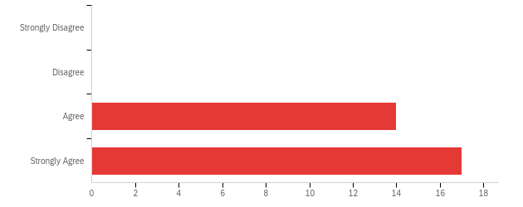

# | Field | Minimum | Maximum | Mean | Std Deviation | Variance | Count
1 | Overall, [ExternalDataReference]'s preparation/route to certification effectively prepared him/her to have a positive impact on P12 student learning and development. | 3.00 | 4.00 | 3.55 | 0.50 | 0.25 | 31

# | Answer | % | Count
1 | Strongly Disagree | 0.00% | 0
2 | Disagree | 0.00% | 0
3 | Agree | 45.16% | 14
4 | Strongly Agree | 54.84% | 17
 | Total | 100% | 31

Q8 - Considering [ExternalDataReference]'s preparation in light of the needs of your school, what are your recommendations for strengthening the teacher's preparation?
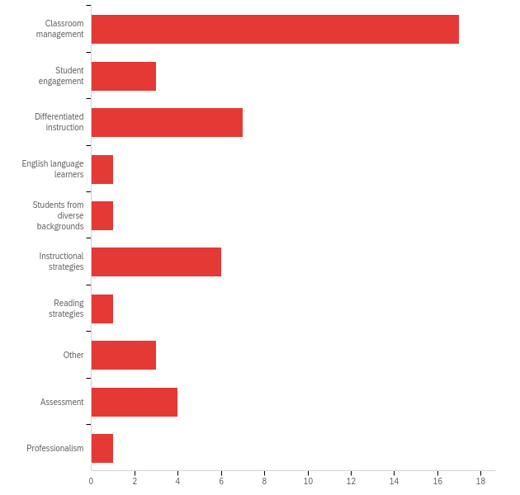

# | Answer | % | Count
1 | Classroom management | 38.64% | 17
2 | Student engagement | 6.82% | 3
3 | Differentiated instruction | 15.91% | 7
4 | English language learners | 2.27% | 1
5 | Students from diverse backgrounds | 2.27% | 1
6 | Instructional strategies | 13.64% | 6
7 | Reading strategies | 2.27% | 1
8 | Other | 6.82% | 3
9 | Assessment | 9.09% | 4
10 | Professionalism | 2.27% | 1
 | Total | 100% | 44

Q8_8_TEXT - Other
Other - Text
Working with parents

Q9 - [ExternalDataReference] received his/her preparation at which of the following institutions? If the teacher has an alternative or emergency certificate, please select Oklahoma State Department of Education.
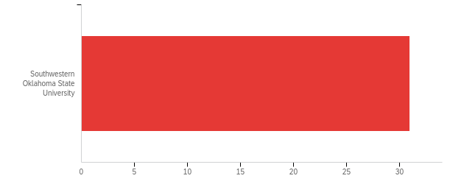

# | Field | Minimum | Maximum | Mean | Std Deviation | Variance | Count
1 | [ExternalDataReference] received his/her preparation at which of the following institutions? If the teacher has an alternative or emergency certificate, please select Oklahoma State Department of Education. | 25.00 | 25.00 | 25.00 | 0.00 | 0.00 | 31

# | Answer | % | Count
22 | Southwestern Oklahoma State University | 100.00% | 31
 | Total | 100% | 31

Q10 - [ExternalDataReference] received his/her license via:
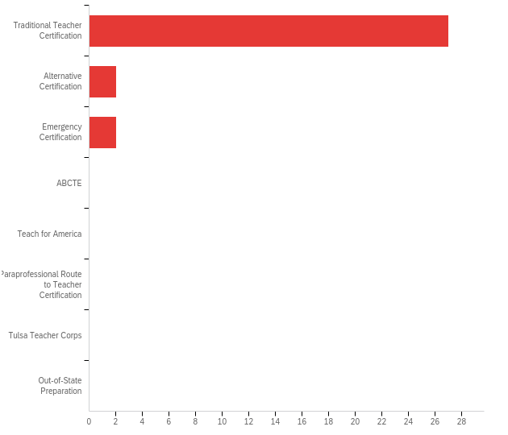

# | Field | Minimum | Maximum | Mean | Std Deviation | Variance | Count
1 | [ExternalDataReference] received his/her license via: | 1.00 | 3.00 | 1.19 | 0.53 | 0.29 | 31

# | Answer | % | Count
1 | Traditional Teacher Certification | 87.10% | 27
2 | Alternative Certification | 6.45% | 2
3 | Emergency Certification | 6.45% | 2
4 | ABCTE | 0.00% | 0
5 | Teach for America | 0.00% | 0
6 | Paraprofessional Route to Teacher Certification | 0.00% | 0
7 | Tulsa Teacher Corps | 0.00% | 0
8 | Out-of-State Preparation | 0.00% | 0
 | Total | 100% | 31

Q11 - In what area was [ExternalDataReference] initially certified? (Please check all that apply)
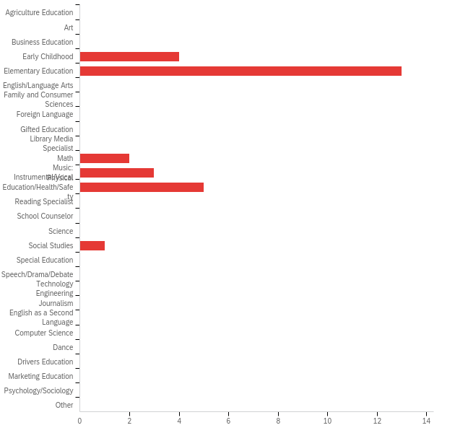

# | Answer | % | Count
1 | Agriculture Education | 0.00% | 0
2 | Art | 0.00% | 0
3 | Business Education | 0.00% | 0
4 | Early Childhood | 14.29% | 4
5 | Elementary Education | 46.43% | 13
6 | English/Language Arts | 0.00% | 0
7 | Family and Consumer Sciences | 0.00% | 0
8 | Foreign Language | 0.00% | 0
9 | Gifted Education | 0.00% | 0
10 | Library Media Specialist | 0.00% | 0
11 | Math | 7.14% | 2
12 | Music: Instrumental/Vocal | 10.71% | 3
13 | Physical Education/Health/Safety | 17.86% | 5
14 | Reading Specialist | 0.00% | 0
15 | School Counselor | 0.00% | 0
16 | Science | 0.00% | 0
17 | Social Studies | 3.57% | 1
18 | Special Education | 0.00% | 0
19 | Speech/Drama/Debate | 0.00% | 0
20 | Technology Engineering | 0.00% | 0
21 | Journalism | 0.00% | 0
22 | English as a Second Language | 0.00% | 0
23 | Computer Science | 0.00% | 0
24 | Dance | 0.00% | 0
25 | Drivers Education | 0.00% | 0
26 | Marketing Education | 0.00% | 0
27 | Psychology/Sociology | 0.00% | 0
35 | Other | 0.00% | 0
 | Total | 100% | 28

Q11_35_TEXT - Other
Other - Text

Q12 - What is [ExternalDataReference]'s primary teaching assignment? (Please check all that apply)
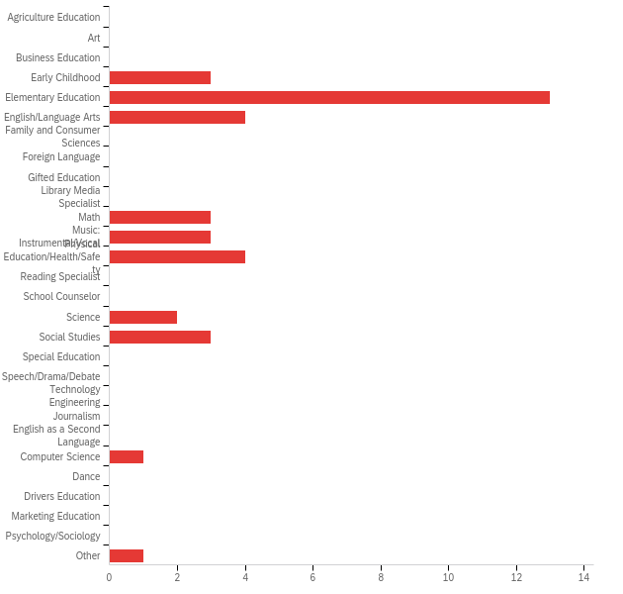

# | Answer | % | Count
1 | Agriculture Education | 0.00% | 0
2 | Art | 0.00% | 0
3 | Business Education | 0.00% | 0
4 | Early Childhood | 8.11% | 3
5 | Elementary Education | 35.14% | 13
6 | English/Language Arts | 10.81% | 4
7 | Family and Consumer Sciences | 0.00% | 0
8 | Foreign Language | 0.00% | 0
9 | Gifted Education | 0.00% | 0
10 | Library Media Specialist | 0.00% | 0
11 | Math | 8.11% | 3
12 | Music: Instrumental/Vocal | 8.11% | 3
13 | Physical Education/Health/Safety | 10.81% | 4
14 | Reading Specialist | 0.00% | 0
15 | School Counselor | 0.00% | 0
16 | Science | 5.41% | 2
17 | Social Studies | 8.11% | 3
18 | Special Education | 0.00% | 0
19 | Speech/Drama/Debate | 0.00% | 0
20 | Technology Engineering | 0.00% | 0
21 | Journalism | 0.00% | 0
22 | English as a Second Language | 0.00% | 0
23 | Computer Science | 2.70% | 1
24 | Dance | 0.00% | 0
25 | Drivers Education | 0.00% | 0
26 | Marketing Education | 0.00% | 0
27 | Psychology/Sociology | 0.00% | 0
35 | Other | 2.70% | 1
 | Total | 100% | 37

Q12_35_TEXT - Other
Other - Text

Q13 - Please share some ideas on improving the mentorship experience.

Please share some ideas on improving the mentorship experience.
I don't think that it needs improving.
I believe the biggest thing that would help a mentor and a mentee is scheduling regular times of observation and reflection.
I think it’s a good program.
Teacher candidates need more training and field experience in classroom management.
It was a great experience. I enjoyed working with WPS and SWOSU while being Coach Lowe's mentor.
First year teachers near more preparation in the areas of communication with external stakeholders and classroom management. Classroom management becomes easier over time, but so many students have trauma and mental health issues that new teachers aren't prepared for.
First year teachers near more preparation in the areas of communication with external stakeholders and classroom management. Classroom management becomes easier over time, but so many students have trauma and mental health issues that new teachers aren't prepared for. Mrs. James has the best of intentions when communicating with families, parents, and students. She can come across as sarcastic at times, even though she does not intend on offending anyone.
First year teachers near more preparation in the areas of communication with external stakeholders and classroom management. Classroom management becomes easier over time, but so many students have trauma and mental health issues that new teachers aren't prepared for.
No , I think she is doing a very good job.
Everything went smoothly~Danyelle is easy to work with!
I would love more time to be able to go and sit in and watch the first year teachers.
More one on one time

