Southwestern Oklahoma State University FYT Report 2022
OEQA First Year Teacher Survey 2022
June 21st 2022, 11:56 am CDT
Q2 - Are you a first year teacher?
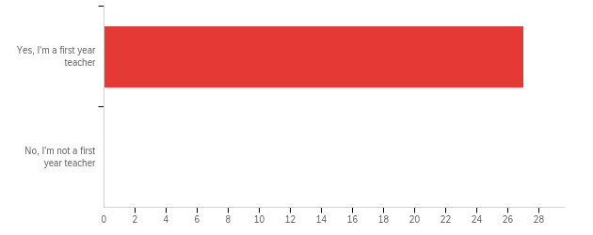

# | Field | Minimum | Maximum | Mean | Std Deviation | Variance | Count
1 | Are you a first year teacher? | 1.00 | 1.00 | 1.00 | 0.00 | 0.00 | 27

# | Answer | % | Count
1 | Yes, I'm a first year teacher | 100.00% | 27
2 | No, I'm not a first year teacher | 0.00% | 0
 | Total | 100% | 27

Q3 - Through which route did you receive your teaching license?
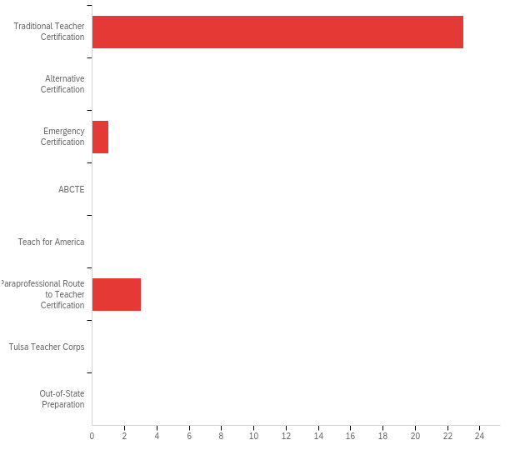

# | Field | Minimum | Maximum | Mean | Std Deviation | Variance | Count
1 | Through which route did you receive your teaching license? | 1.00 | 6.00 | 1.63 | 1.59 | 2.53 | 27

# | Answer | % | Count
1 | Traditional Teacher Certification | 85.19% | 23
2 | Alternative Certification | 0.00% | 0
3 | Emergency Certification | 3.70% | 1
4 | ABCTE | 0.00% | 0
5 | Teach for America | 0.00% | 0
6 | Paraprofessional Route to Teacher Certification | 11.11% | 3
7 | Tulsa Teacher Corps | 0.00% | 0
8 | Out-of-State Preparation | 0.00% | 0
 | Total | 100% | 27

Q4 - From which of the following institutions did you receive recommendation for teacher certification? If you hold an alternative or emergency certificate please select Oklahoma State Department of Education.
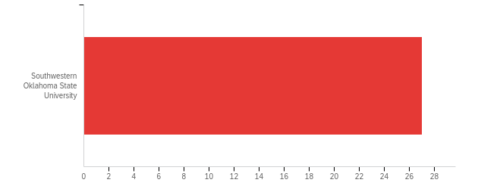

# | Field | Minimum | Maximum | Mean | Std Deviation | Variance | Count
1 | From which of the following institutions did you receive recommendation for teacher certification? If you hold an alternative or emergency certificate please select Oklahoma State Department of Education. | 26.00 | 26.00 | 26.00 | 0.00 | 0.00 | 27

# | Answer | % | Count
12 | Southwestern Oklahoma State University | 100.00% | 27
 | Total | 100% | 27

Q6 - In what area did you receive your degree?
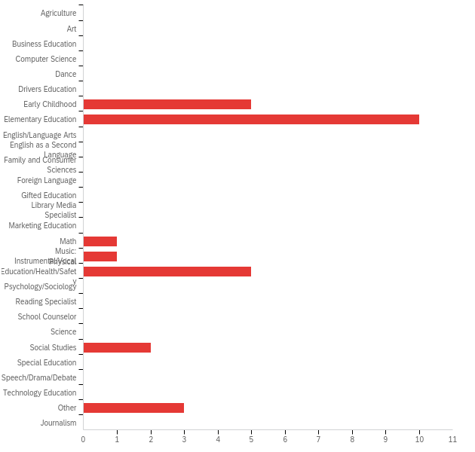

# | Answer | % | Count
1 | Agriculture | 0.00% | 0
2 | Art | 0.00% | 0
3 | Business Education | 0.00% | 0
4 | Computer Science | 0.00% | 0
5 | Dance | 0.00% | 0
6 | Drivers Education | 0.00% | 0
7 | Early Childhood | 18.52% | 5
8 | Elementary Education | 37.04% | 10
9 | English/Language Arts | 0.00% | 0
10 | English as a Second Language | 0.00% | 0
11 | Family and Consumer Sciences | 0.00% | 0
12 | Foreign Language | 0.00% | 0
13 | Gifted Education | 0.00% | 0
14 | Library Media Specialist | 0.00% | 0
15 | Marketing Education | 0.00% | 0
16 | Math | 3.70% | 1
17 | Music: Instrumental/Vocal | 3.70% | 1
18 | Physical Education/Health/Safety | 18.52% | 5
19 | Psychology/Sociology | 0.00% | 0
20 | Reading Specialist | 0.00% | 0
21 | School Counselor | 0.00% | 0
22 | Science | 0.00% | 0
23 | Social Studies | 7.41% | 2
24 | Special Education | 0.00% | 0
25 | Speech/Drama/Debate | 0.00% | 0
26 | Technology Education | 0.00% | 0
27 | Other | 11.11% | 3
28 | Journalism | 0.00% | 0
 | Total | 100% | 27

Q6_27_TEXT - Other
Other - Text
Arts and Sciences
Bach. of Interdisciplinary studies focused on Early Childhood Education and Special Education

Q7 - In what year did you receive your degree?
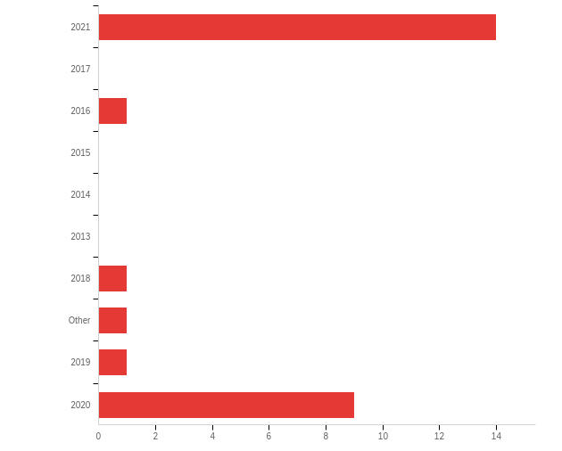

# | Field | Minimum | Maximum | Mean | Std Deviation | Variance | Count
1 | In what year did you receive your degree? - Selected Choice | 1.00 | 10.00 | 4.85 | 4.22 | 17.83 | 27

# | Answer | % | Count
1 | 2021 | 51.85% | 14
2 | 2017 | 0.00% | 0
3 | 2016 | 3.70% | 1
4 | 2015 | 0.00% | 0
5 | 2014 | 0.00% | 0
6 | 2013 | 0.00% | 0
7 | 2018 | 3.70% | 1
8 | Other | 3.70% | 1
9 | 2019 | 3.70% | 1
10 | 2020 | 33.33% | 9
 | Total | 100% | 27

Q7_8_TEXT - Other
Other - Text
2008

Q8 - The Learner and Learning Please rate the extent to which you agree with each statement below. My preparation program/route to certification prepared me to:
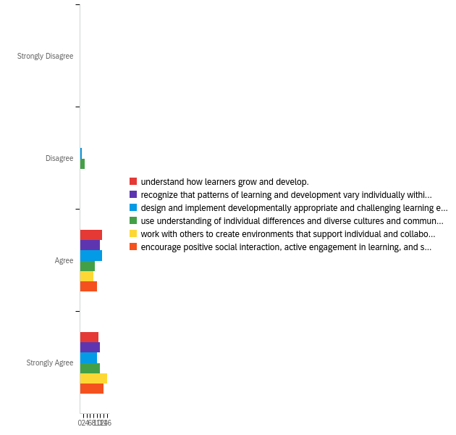

# | Field | Minimum | Maximum | Mean | Std Deviation | Variance | Count
1 | understand how learners grow and develop. | 3.00 | 4.00 | 3.46 | 0.50 | 0.25 | 24
2 | recognize that patterns of learning and development vary individually within and across the cognitive, linguistic, social, emotional, and physical areas. | 3.00 | 4.00 | 3.50 | 0.50 | 0.25 | 24
3 | design and implement developmentally appropriate and challenging learning experiences. | 2.00 | 4.00 | 3.38 | 0.56 | 0.32 | 24
4 | use understanding of individual differences and diverse cultures and communities to ensure inclusive learning environments that enable each learner to meet high standards. | 2.00 | 4.00 | 3.38 | 0.70 | 0.48 | 24
5 | work with others to create environments that support individual and collaborative learning. | 3.00 | 4.00 | 3.67 | 0.47 | 0.22 | 24
6 | encourage positive social interaction, active engagement in learning, and self-motivation. | 3.00 | 4.00 | 3.58 | 0.49 | 0.24 | 24

# | Question | Strongly Disagree |  | Disagree |  | Agree |  | Strongly Agree |  | Total
1 | understand how learners grow and develop. | 0.00% | 0 | 0.00% | 0 | 54.17% | 13 | 45.83% | 11 | 24
2 | recognize that patterns of learning and development vary individually within and across the cognitive, linguistic, social, emotional, and physical areas. | 0.00% | 0 | 0.00% | 0 | 50.00% | 12 | 50.00% | 12 | 24
3 | design and implement developmentally appropriate and challenging learning experiences. | 0.00% | 0 | 4.17% | 1 | 54.17% | 13 | 41.67% | 10 | 24
4 | use understanding of individual differences and diverse cultures and communities to ensure inclusive learning environments that enable each learner to meet high standards. | 0.00% | 0 | 12.50% | 3 | 37.50% | 9 | 50.00% | 12 | 24
5 | work with others to create environments that support individual and collaborative learning. | 0.00% | 0 | 0.00% | 0 | 33.33% | 8 | 66.67% | 16 | 24
6 | encourage positive social interaction, active engagement in learning, and self-motivation. | 0.00% | 0 | 0.00% | 0 | 41.67% | 10 | 58.33% | 14 | 24

Q9 - Content Please rate the extent to which you agree with each statement below. My preparation program/route to certification prepared me to:
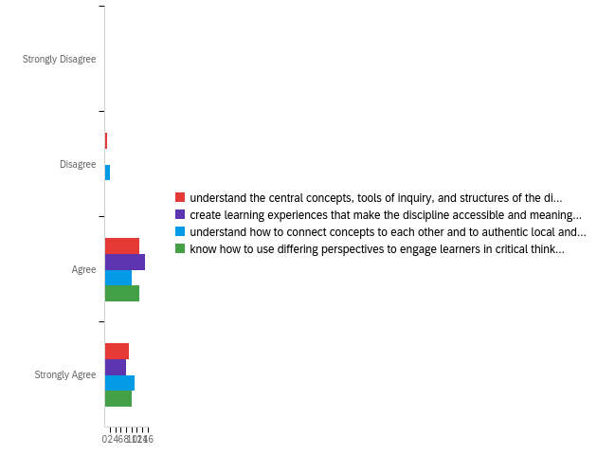

# | Field | Minimum | Maximum | Mean | Std Deviation | Variance | Count
1 | understand the central concepts, tools of inquiry, and structures of the discipline(s) I teach. | 2.00 | 4.00 | 3.35 | 0.56 | 0.31 | 23
2 | create learning experiences that make the discipline accessible and meaningful for learners to assure mastery of the content. | 3.00 | 4.00 | 3.35 | 0.48 | 0.23 | 23
3 | understand how to connect concepts to each other and to authentic local and global issues. | 2.00 | 4.00 | 3.39 | 0.64 | 0.41 | 23
4 | know how to use differing perspectives to engage learners in critical thinking, creativity, and collaborative problem solving. | 3.00 | 4.00 | 3.43 | 0.50 | 0.25 | 23

# | Question | Strongly Disagree |  | Disagree |  | Agree |  | Strongly Agree |  | Total
1 | understand the central concepts, tools of inquiry, and structures of the discipline(s) I teach. | 0.00% | 0 | 4.35% | 1 | 56.52% | 13 | 39.13% | 9 | 23
2 | create learning experiences that make the discipline accessible and meaningful for learners to assure mastery of the content. | 0.00% | 0 | 0.00% | 0 | 65.22% | 15 | 34.78% | 8 | 23
3 | understand how to connect concepts to each other and to authentic local and global issues. | 0.00% | 0 | 8.70% | 2 | 43.48% | 10 | 47.83% | 11 | 23
4 | know how to use differing perspectives to engage learners in critical thinking, creativity, and collaborative problem solving. | 0.00% | 0 | 0.00% | 0 | 56.52% | 13 | 43.48% | 10 | 23

Q10 - Instructional Practice Please rate the extent to which you agree with each statement below. My preparation program/route to certification prepared me to:
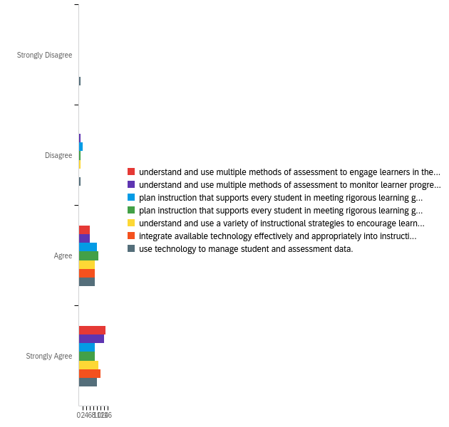

# | Field | Minimum | Maximum | Mean | Std Deviation | Variance | Count
1 | understand and use multiple methods of assessment to engage learners in their own growth and guide learners' decision making. | 3.00 | 4.00 | 3.71 | 0.45 | 0.20 | 21
2 | understand and use multiple methods of assessment to monitor learner progress and to guide my decision making. | 2.00 | 4.00 | 3.62 | 0.58 | 0.33 | 21
3 | plan instruction that supports every student in meeting rigorous learning goals by drawing upon knowledge of content areas, curriculum, cross-disciplinary skills, and pedagogy. | 2.00 | 4.00 | 3.33 | 0.64 | 0.41 | 21
4 | plan instruction that supports every student in meeting rigorous learning goals by drawing upon knowledge of learners and the community context. | 2.00 | 4.00 | 3.38 | 0.58 | 0.33 | 21
5 | understand and use a variety of instructional strategies to encourage learners to develop deep understanding of content areas and their connections, and to build skills to apply knowledge in meaningful ways. | 2.00 | 4.00 | 3.48 | 0.59 | 0.34 | 21
6 | integrate available technology effectively and appropriately into instruction. | 3.00 | 4.00 | 3.57 | 0.49 | 0.24 | 21
7 | use technology to manage student and assessment data. | 1.00 | 4.00 | 3.33 | 0.78 | 0.60 | 21

# | Question | Strongly Disagree |  | Disagree |  | Agree |  | Strongly Agree |  | Total
1 | understand and use multiple methods of assessment to engage learners in their own growth and guide learners' decision making. | 0.00% | 0 | 0.00% | 0 | 28.57% | 6 | 71.43% | 15 | 21
2 | understand and use multiple methods of assessment to monitor learner progress and to guide my decision making. | 0.00% | 0 | 4.76% | 1 | 28.57% | 6 | 66.67% | 14 | 21
3 | plan instruction that supports every student in meeting rigorous learning goals by drawing upon knowledge of content areas, curriculum, cross-disciplinary skills, and pedagogy. | 0.00% | 0 | 9.52% | 2 | 47.62% | 10 | 42.86% | 9 | 21
4 | plan instruction that supports every student in meeting rigorous learning goals by drawing upon knowledge of learners and the community context. | 0.00% | 0 | 4.76% | 1 | 52.38% | 11 | 42.86% | 9 | 21
5 | understand and use a variety of instructional strategies to encourage learners to develop deep understanding of content areas and their connections, and to build skills to apply knowledge in meaningful ways. | 0.00% | 0 | 4.76% | 1 | 42.86% | 9 | 52.38% | 11 | 21
6 | integrate available technology effectively and appropriately into instruction. | 0.00% | 0 | 0.00% | 0 | 42.86% | 9 | 57.14% | 12 | 21
7 | use technology to manage student and assessment data. | 4.76% | 1 | 4.76% | 1 | 42.86% | 9 | 47.62% | 10 | 21

Q11 - Professional Responsibility Please rate the extent to which you agree with each statement below. My preparation program/route to certification prepared me to:
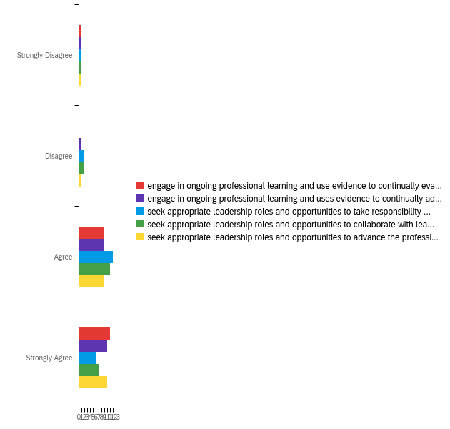

# | Field | Minimum | Maximum | Mean | Std Deviation | Variance | Count
1 | engage in ongoing professional learning and use evidence to continually evaluate my practice, particularly the effects of my choices and actions on others (learners, families, other professionals, and the community). | 1.00 | 4.00 | 3.43 | 0.73 | 0.53 | 21
2 | engage in ongoing professional learning and uses evidence to continually adapt practice to meet the needs of each learner. | 1.00 | 4.00 | 3.33 | 0.78 | 0.60 | 21
3 | seek appropriate leadership roles and opportunities to take responsibility for student learning. | 1.00 | 4.00 | 3.10 | 0.75 | 0.56 | 21
4 | seek appropriate leadership roles and opportunities to collaborate with learners, families, colleagues, other school professionals, and community members to ensure learner growth. | 1.00 | 4.00 | 3.14 | 0.77 | 0.60 | 21
5 | seek appropriate leadership roles and opportunities to advance the profession. | 1.00 | 4.00 | 3.33 | 0.78 | 0.60 | 21

# | Question | Strongly Disagree |  | Disagree |  | Agree |  | Strongly Agree |  | Total
1 | engage in ongoing professional learning and use evidence to continually evaluate my practice, particularly the effects of my choices and actions on others (learners, families, other professionals, and the community). | 4.76% | 1 | 0.00% | 0 | 42.86% | 9 | 52.38% | 11 | 21
2 | engage in ongoing professional learning and uses evidence to continually adapt practice to meet the needs of each learner. | 4.76% | 1 | 4.76% | 1 | 42.86% | 9 | 47.62% | 10 | 21
3 | seek appropriate leadership roles and opportunities to take responsibility for student learning. | 4.76% | 1 | 9.52% | 2 | 57.14% | 12 | 28.57% | 6 | 21
4 | seek appropriate leadership roles and opportunities to collaborate with learners, families, colleagues, other school professionals, and community members to ensure learner growth. | 4.76% | 1 | 9.52% | 2 | 52.38% | 11 | 33.33% | 7 | 21
5 | seek appropriate leadership roles and opportunities to advance the profession. | 4.76% | 1 | 4.76% | 1 | 42.86% | 9 | 47.62% | 10 | 21

Q12 - Overall, my preparation/route to certification effectively prepared me to have a positive impact on P12 student learning and development.
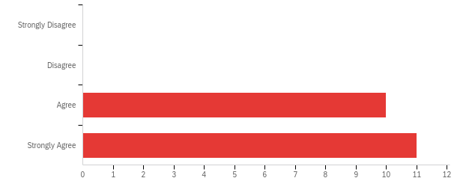

# | Field | Minimum | Maximum | Mean | Std Deviation | Variance | Count
1 | Overall, my preparation/route to certification effectively prepared me to have a positive impact on P12 student learning and development. | 3.00 | 4.00 | 3.52 | 0.50 | 0.25 | 21

# | Answer | % | Count
1 | Strongly Disagree | 0.00% | 0
2 | Disagree | 0.00% | 0
3 | Agree | 47.62% | 10
4 | Strongly Agree | 52.38% | 11
 | Total | 100% | 21

Q13 - What courses or experiences in your educator preparation/route to certification stand out as particularly important or meaningful?
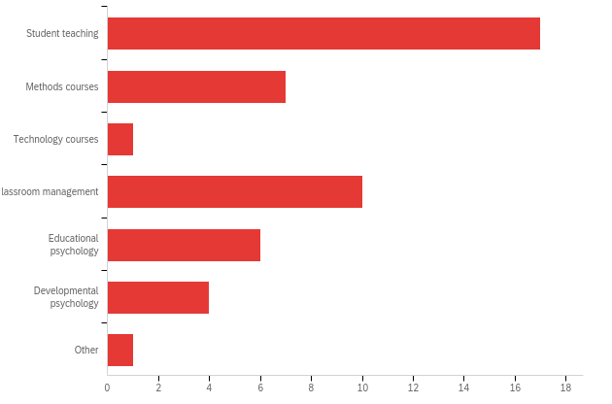

# | Answer | % | Count
10 | Student teaching | 36.96% | 17
11 | Methods courses | 15.22% | 7
12 | Technology courses | 2.17% | 1
13 | Classroom management | 21.74% | 10
14 | Educational psychology | 13.04% | 6
15 | Developmental psychology | 8.70% | 4
16 | Other | 2.17% | 1
 | Total | 100% | 46

Q13_16_TEXT - Other
Other - Text
Observations, anything to get into the classrooms.

Q14 - As you near the end of your first year of teaching, in what area(s) could you have used more preparation? (Please check all that apply)
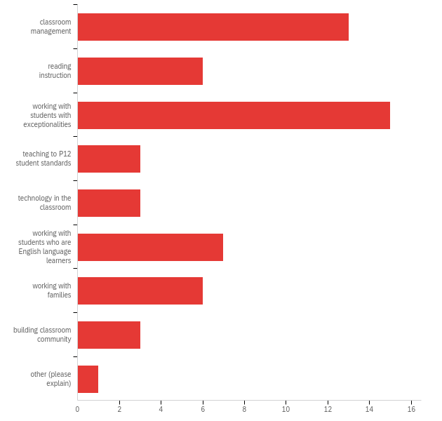

# | Answer | % | Count
1 | classroom management | 22.81% | 13
2 | reading instruction | 10.53% | 6
3 | working with students with exceptionalities | 26.32% | 15
4 | teaching to P12 student standards | 5.26% | 3
5 | technology in the classroom | 5.26% | 3
6 | working with students who are English language learners | 12.28% | 7
7 | working with families | 10.53% | 6
8 | building classroom community | 5.26% | 3
9 | other (please explain) | 1.75% | 1
 | Total | 100% | 57

Q14_9_TEXT - other (please explain)
other (please explain) - Text
Pacing Guides/Curriculum Maps

Q15 - Please note awards or honors received, degrees or certificates earned, and other recognitions from the current school year.

Please note awards or honors received, degrees or certificates earned, and other recognitions from the current school year.
Magna Cum Laude, Bachelor of Science in Education, Oklahoma Teaching certificate for Elementary Education and Early Childhood Education
n/a
AWARE Teacher of the month of March
I have received my certification in Instrumental/General Music.
BA elementary ed.
I added business education to my certification.

Q16 - Were you assigned a mentor from your school district this school year?
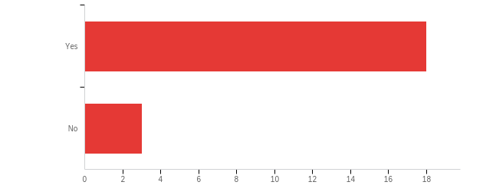

# | Field | Minimum | Maximum | Mean | Std Deviation | Variance | Count
1 | Were you assigned a mentor from your school district this school year? | 1.00 | 2.00 | 1.14 | 0.35 | 0.12 | 21

# | Answer | % | Count
1 | Yes | 85.71% | 18
2 | No | 14.29% | 3
 | Total | 100% | 21

Q17 - How much time did you spend with your mentor teacher?
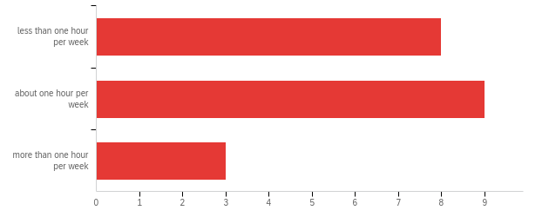

# | Field | Minimum | Maximum | Mean | Std Deviation | Variance | Count
1 | How much time did you spend with your mentor teacher? | 1.00 | 3.00 | 1.75 | 0.70 | 0.49 | 20

# | Answer | % | Count
1 | less than one hour per week | 40.00% | 8
2 | about one hour per week | 45.00% | 9
3 | more than one hour per week | 15.00% | 3
 | Total | 100% | 20

Q18 - Is your mentor in your same teaching area?
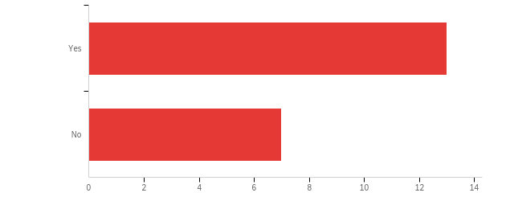

# | Field | Minimum | Maximum | Mean | Std Deviation | Variance | Count
1 | Is your mentor in your same teaching area? | 1.00 | 2.00 | 1.35 | 0.48 | 0.23 | 20

# | Answer | % | Count
1 | Yes | 65.00% | 13
2 | No | 35.00% | 7
 | Total | 100% | 20

Q19 - How satisfied are you with your mentoring experience?
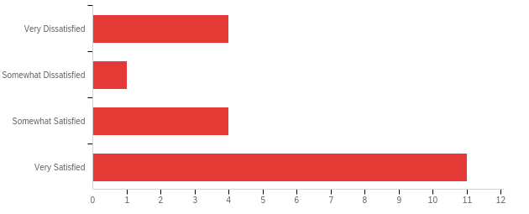

# | Field | Minimum | Maximum | Mean | Std Deviation | Variance | Count
1 | How satisfied are you with your mentoring experience? | 1.00 | 4.00 | 3.10 | 1.18 | 1.39 | 20

# | Answer | % | Count
1 | Very Dissatisfied | 20.00% | 4
2 | Somewhat Dissatisfied | 5.00% | 1
3 | Somewhat Satisfied | 20.00% | 4
4 | Very Satisfied | 55.00% | 11
 | Total | 100% | 20

Q20 - How might the mentoring experience be improved?
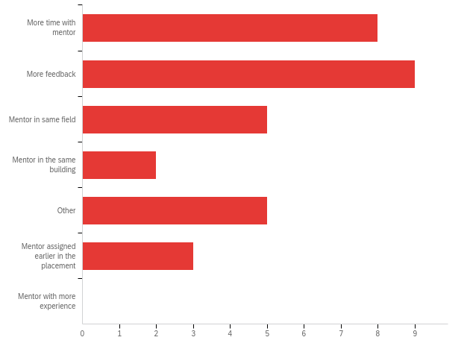

# | Answer | % | Count
1 | More time with mentor | 25.00% | 8
2 | More feedback | 28.13% | 9
3 | Mentor in same field | 15.63% | 5
4 | Mentor in the same building | 6.25% | 2
5 | Other | 15.63% | 5
6 | Mentor assigned earlier in the placement | 9.38% | 3
7 | Mentor with more experience | 0.00% | 0
 | Total | 100% | 32

Q20_5_TEXT - Other
Other - Text
Having an assigned Mentor
N/A
Mentor who understood my challenges in the classroom this year
Mentor in same hallway

Q10 - In what area(s) were you initially certified? (Please check all that apply)
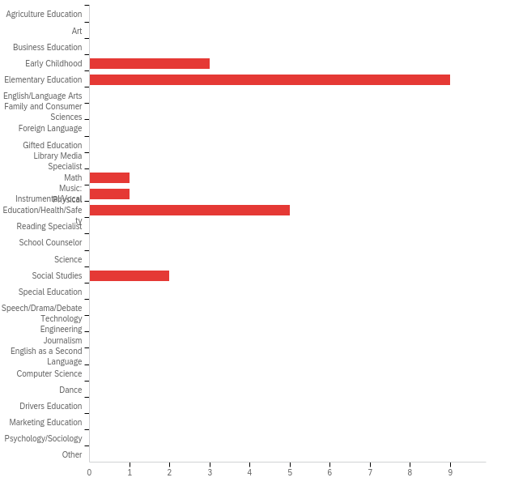

# | Answer | % | Count
1 | Agriculture Education | 0.00% | 0
2 | Art | 0.00% | 0
3 | Business Education | 0.00% | 0
4 | Early Childhood | 14.29% | 3
5 | Elementary Education | 42.86% | 9
6 | English/Language Arts | 0.00% | 0
7 | Family and Consumer Sciences | 0.00% | 0
8 | Foreign Language | 0.00% | 0
9 | Gifted Education | 0.00% | 0
10 | Library Media Specialist | 0.00% | 0
11 | Math | 4.76% | 1
12 | Music: Instrumental/Vocal | 4.76% | 1
13 | Physical Education/Health/Safety | 23.81% | 5
14 | Reading Specialist | 0.00% | 0
15 | School Counselor | 0.00% | 0
16 | Science | 0.00% | 0
17 | Social Studies | 9.52% | 2
18 | Special Education | 0.00% | 0
19 | Speech/Drama/Debate | 0.00% | 0
20 | Technology Engineering | 0.00% | 0
21 | Journalism | 0.00% | 0
22 | English as a Second Language | 0.00% | 0
23 | Computer Science | 0.00% | 0
24 | Dance | 0.00% | 0
25 | Drivers Education | 0.00% | 0
26 | Marketing Education | 0.00% | 0
27 | Psychology/Sociology | 0.00% | 0
35 | Other | 0.00% | 0
 | Total | 100% | 21

Q10_35_TEXT - Other
Other - Text

Q22 - What is your current primary teaching assignment? (Please check all that apply)
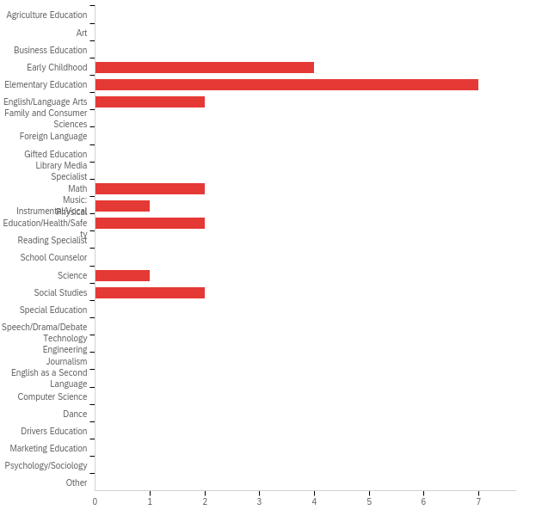

# | Answer | % | Count
1 | Agriculture Education | 0.00% | 0
2 | Art | 0.00% | 0
3 | Business Education | 0.00% | 0
4 | Early Childhood | 19.05% | 4
5 | Elementary Education | 33.33% | 7
6 | English/Language Arts | 9.52% | 2
7 | Family and Consumer Sciences | 0.00% | 0
8 | Foreign Language | 0.00% | 0
9 | Gifted Education | 0.00% | 0
10 | Library Media Specialist | 0.00% | 0
11 | Math | 9.52% | 2
12 | Music: Instrumental/Vocal | 4.76% | 1
13 | Physical Education/Health/Safety | 9.52% | 2
14 | Reading Specialist | 0.00% | 0
15 | School Counselor | 0.00% | 0
16 | Science | 4.76% | 1
17 | Social Studies | 9.52% | 2
18 | Special Education | 0.00% | 0
19 | Speech/Drama/Debate | 0.00% | 0
20 | Technology Engineering | 0.00% | 0
21 | Journalism | 0.00% | 0
22 | English as a Second Language | 0.00% | 0
23 | Computer Science | 0.00% | 0
24 | Dance | 0.00% | 0
25 | Drivers Education | 0.00% | 0
26 | Marketing Education | 0.00% | 0
27 | Psychology/Sociology | 0.00% | 0
35 | Other | 0.00% | 0
 | Total | 100% | 21

Q22_35_TEXT - Other
Other - Text

Q23 - In what additional area(s) are you certified? (Please check all that apply)
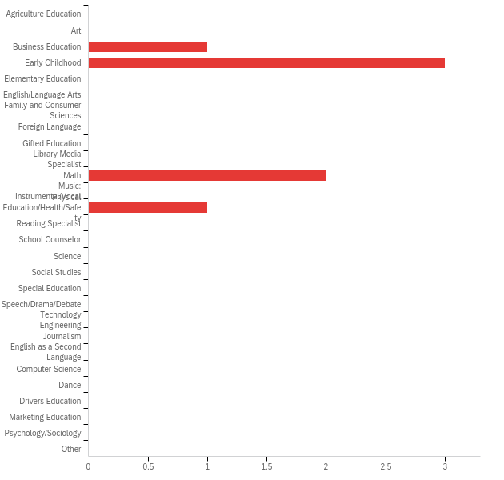

# | Answer | % | Count
1 | Agriculture Education | 0.00% | 0
2 | Art | 0.00% | 0
3 | Business Education | 14.29% | 1
4 | Early Childhood | 42.86% | 3
5 | Elementary Education | 0.00% | 0
6 | English/Language Arts | 0.00% | 0
7 | Family and Consumer Sciences | 0.00% | 0
8 | Foreign Language | 0.00% | 0
9 | Gifted Education | 0.00% | 0
10 | Library Media Specialist | 0.00% | 0
11 | Math | 28.57% | 2
12 | Music: Instrumental/Vocal | 0.00% | 0
13 | Physical Education/Health/Safety | 14.29% | 1
14 | Reading Specialist | 0.00% | 0
15 | School Counselor | 0.00% | 0
16 | Science | 0.00% | 0
17 | Social Studies | 0.00% | 0
18 | Special Education | 0.00% | 0
19 | Speech/Drama/Debate | 0.00% | 0
20 | Technology Engineering | 0.00% | 0
21 | Journalism | 0.00% | 0
22 | English as a Second Language | 0.00% | 0
23 | Computer Science | 0.00% | 0
24 | Dance | 0.00% | 0
25 | Drivers Education | 0.00% | 0
26 | Marketing Education | 0.00% | 0
27 | Psychology/Sociology | 0.00% | 0
35 | Other | 0.00% | 0
 | Total | 100% | 7

Q23_35_TEXT - Other
Other - Text

Q24 - What other roles do you fill at your school? (Please check all that apply)
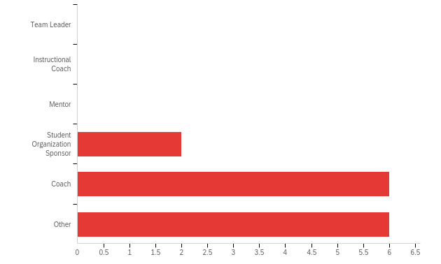

# | Answer | % | Count
1 | Team Leader | 0.00% | 0
2 | Instructional Coach | 0.00% | 0
3 | Mentor | 0.00% | 0
4 | Student Organization Sponsor | 14.29% | 2
5 | Coach | 42.86% | 6
6 | Other | 42.86% | 6
 | Total | 100% | 14

Q25 - Do you teach at a Title I school?
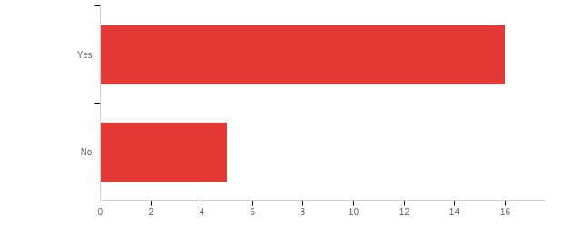

# | Field | Minimum | Maximum | Mean | Std Deviation | Variance | Count
1 | Do you teach at a Title I school? | 1.00 | 2.00 | 1.24 | 0.43 | 0.18 | 21

# | Answer | % | Count
1 | Yes | 76.19% | 16
2 | No | 23.81% | 5
 | Total | 100% | 21

Q26 - Which of the following describes your school district?
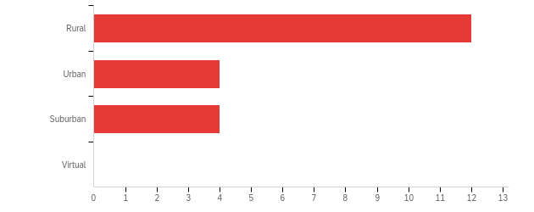

# | Field | Minimum | Maximum | Mean | Std Deviation | Variance | Count
1 | Which of the following describes your school district? | 1.00 | 3.00 | 1.60 | 0.80 | 0.64 | 20

# | Answer | % | Count
1 | Rural | 60.00% | 12
2 | Urban | 20.00% | 4
3 | Suburban | 20.00% | 4
4 | Virtual | 0.00% | 0
 | Total | 100% | 20

Q27 - As a high school student, did you participate in any programs or classes that influenced your decision to become a teacher?
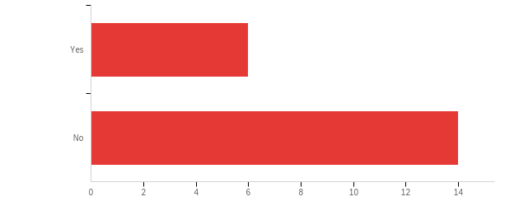

# | Field | Minimum | Maximum | Mean | Std Deviation | Variance | Count
1 | As a high school student, did you participate in any programs or classes that influenced your decision to become a teacher? | 1.00 | 2.00 | 1.70 | 0.46 | 0.21 | 20

# | Answer | % | Count
1 | Yes | 30.00% | 6
2 | No | 70.00% | 14
 | Total | 100% | 20

Q28 - If yes, please describe (e.g., Future Educators of America/Educators Rising, Teacher Cadet, etc.)

If yes, please describe (e.g., Future Educators of America/Educators Rising, Teacher Cadet, etc.)
Exceptional Child
n/a
I was an Aide for a teacher during my senior year.
Band
.
Football
Student council, sports management, link crew, and FCA were all things that gave me great connections with teachers and made me realize I want to do it.
Teaching as a career

Q29 - Do you plan to remain employed as a teacher in Oklahoma next year? If so, please list up to 3 reasons you plan to stay. If not, please list up to 3 reasons you do not plan to stay.

Do you plan to remain employed as a teacher in Oklahoma next year? If so, please list up to 3 reasons you plan to stay. If not, please list up to 3 reasons you do not plan to stay.
Yes, I plan to remain employed as a teacher in Oklahoma next year. I own my home here in Oklahoma. I do not want my children to have to switch schools.
Yes. 1) Continue to help young minds grow 2) Continue to help provide for my family 3) Continue to grow daily as an educator
Yes. The current district I am working in is very community focused and has been great to work for this year!
Yes I love teaching I love coaching I love influencing kids to be better critical thinkers
Yes. I enjoy the profession and I plan to continue to help carve the paths for our next generation.
Yes. I like what I do, my husband makes enough money that I am able to make the pay work and I am excited for the time off.
I plan to stay as a teacher. I love my job. I will stay because there are so many students to be reached. I like feeling like I make a difference and I get that chance with my students. I simply love what I do and I'm passionate about it. I love my kids.
No, I will be starting a new career path after attending 5 years of college. The parents are disrespectful and have ridiculous expectations for what teachers "should be doing". The students have major psychological behavioral problems from situations happening outside of school. The pay is a joke.
Yes I have enjoyed my first year. I am up for the challenge to improve my teaching abilities. I love the team that I work with.
Yes, 1. My family lives here 2. Most of my colleagues teach here. 3. I have been treated well.
Yes. 1. I do not want to move. 2. My fiance is employed here.
Yes 1. Easy commute 2. Close to family 3. Need money
Honestly I'm still deciding. 1. low pay is hard for a single person with bills and student loans 2. my school has not been very supportive 3. I don't want to give up yet
Yes. Retirement I like to coach
Yes. This is what I am passionate about, I am starting in my dream district next year, and I love kids.
Yes. I love the community, the relationships built with staff and students, and I’m extremely happy where I’m at.
My family lives in Oklahoma. I really enjoy where I work. I am proud of the state of Oklahoma.

